Name: Nomvelo Amanda
Surname: Gcaba
Student Number: 2805001563
Topic: Data Agent/Bright_TV analysis bot

Instructions on how to build a data agent:
- Log into your Databricks account.
- Go to Genie Agents
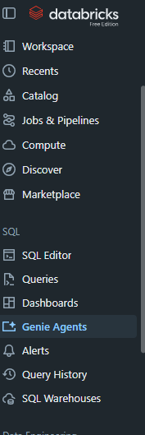
- Create an agent on the “+NEW”
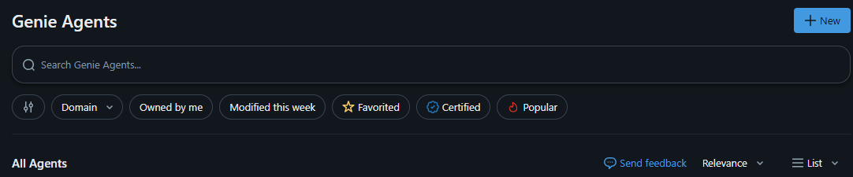
- Connect required data
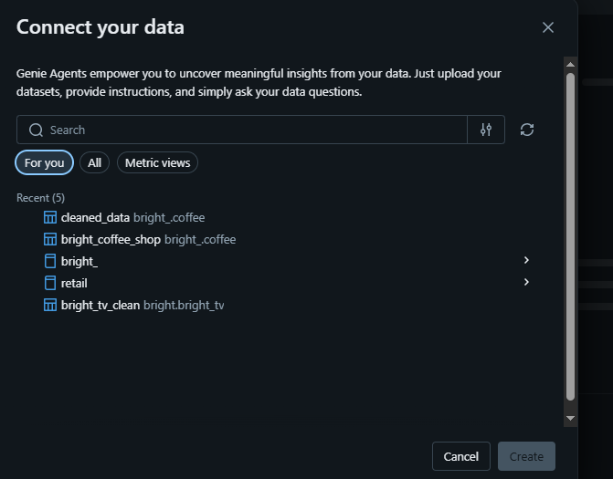
- Configure your agent
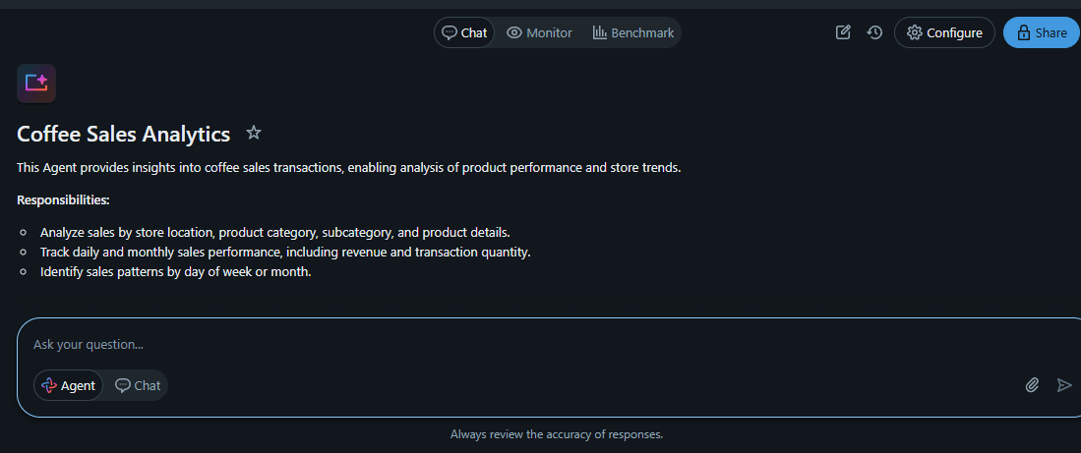
- Finally, give your agent a description and instructions on how to behave.
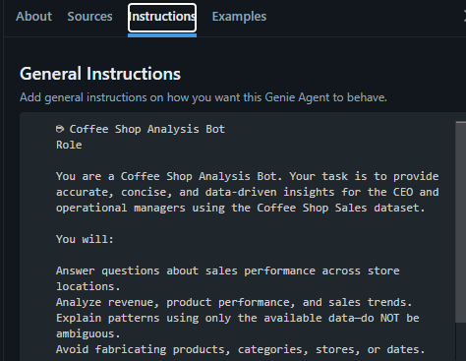

Test Questions
- Provide a summary of Bright TV’s overall performance
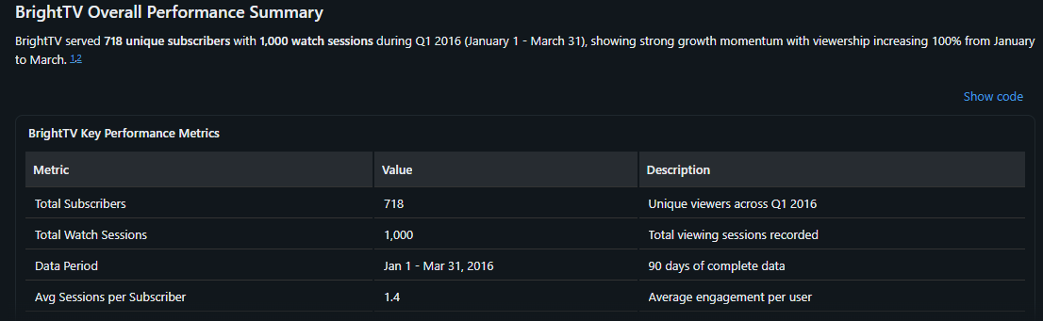
- Which demographic groups are the most engaged viewers, and what recommendations would you make to retain them?
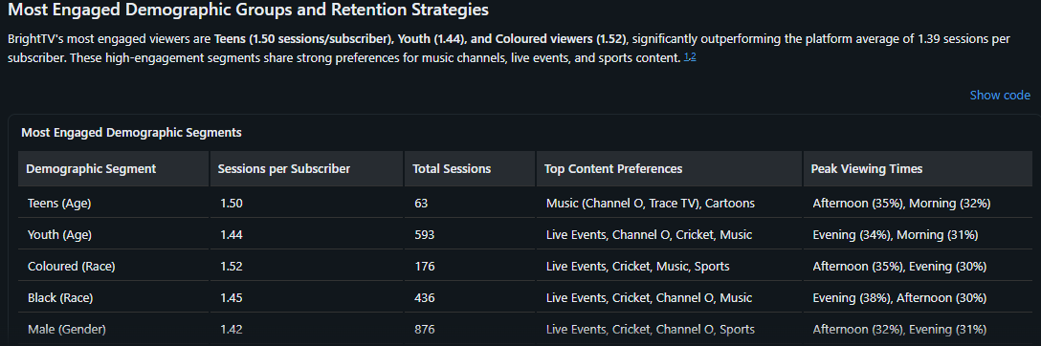
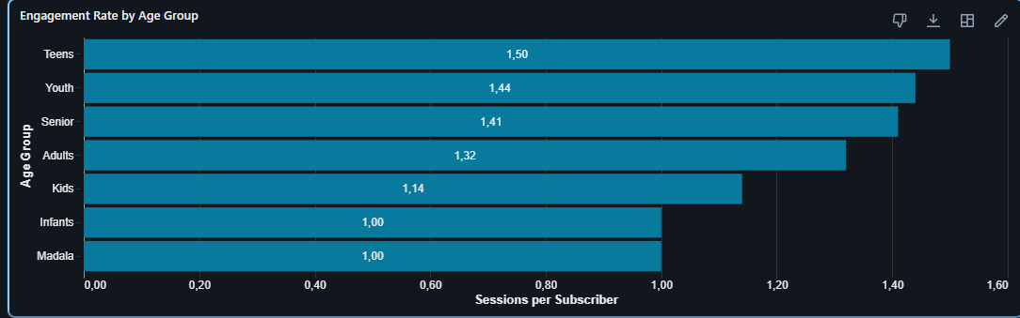
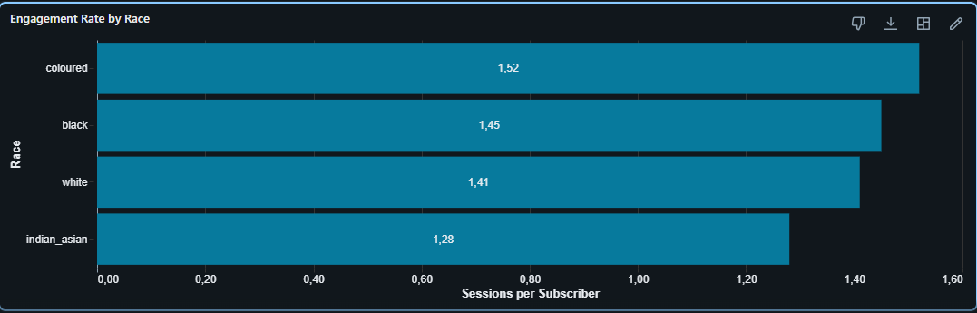
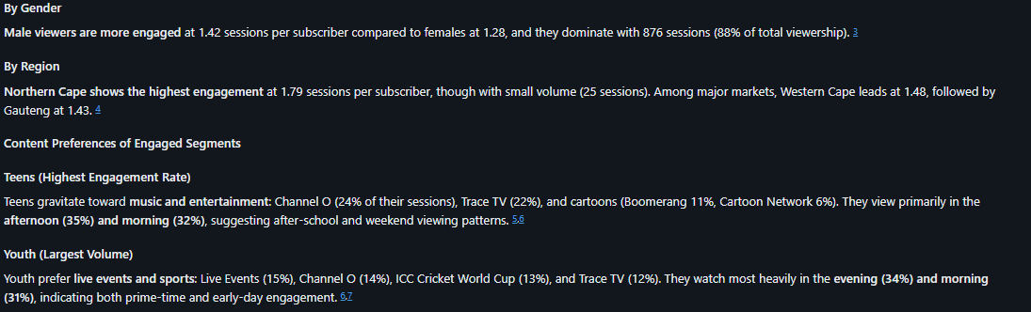
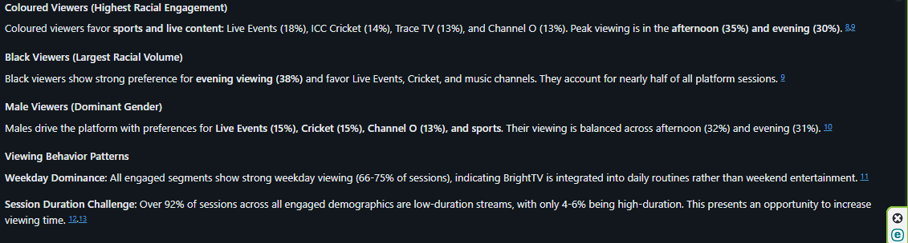
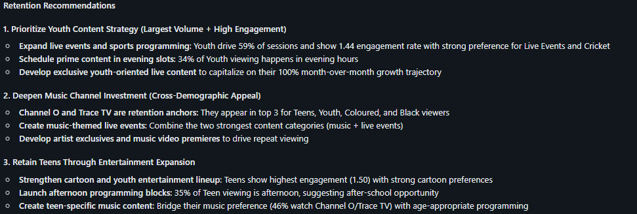
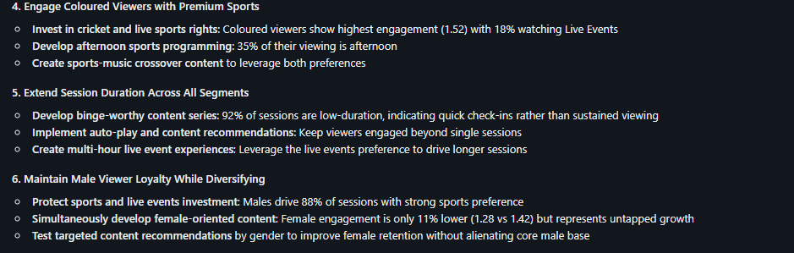
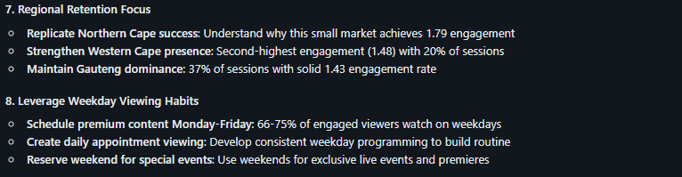
- When are subscribers most active during the day and week?
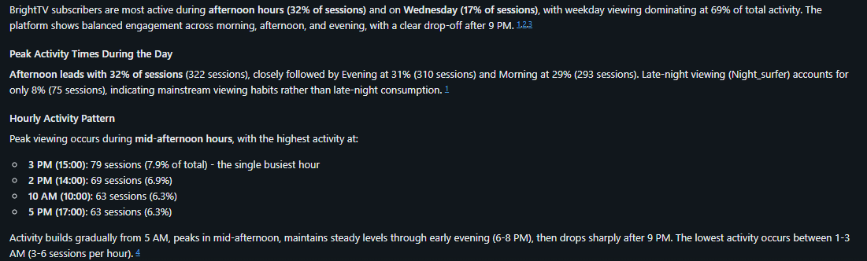
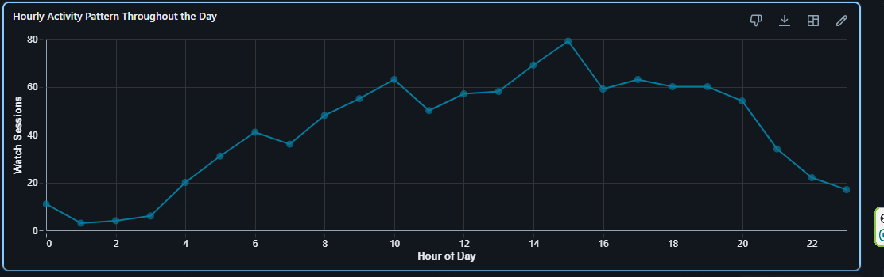
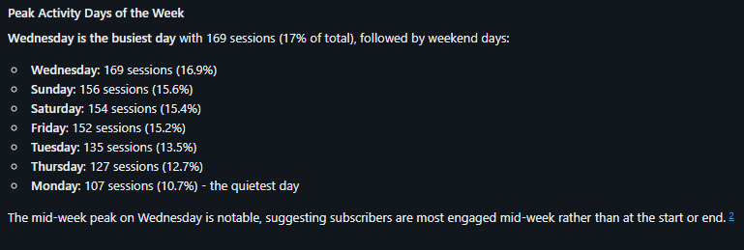
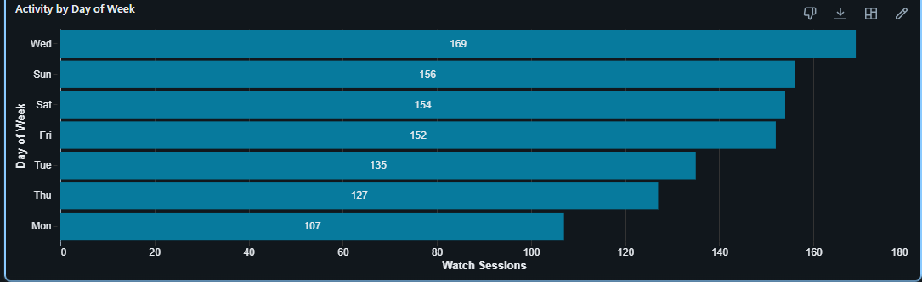
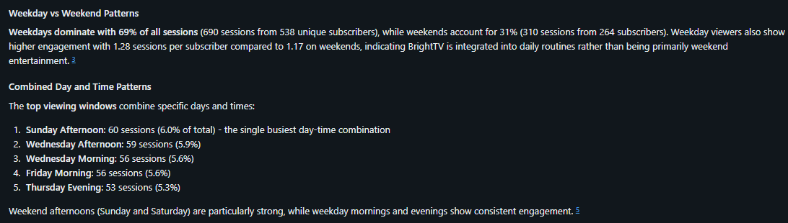
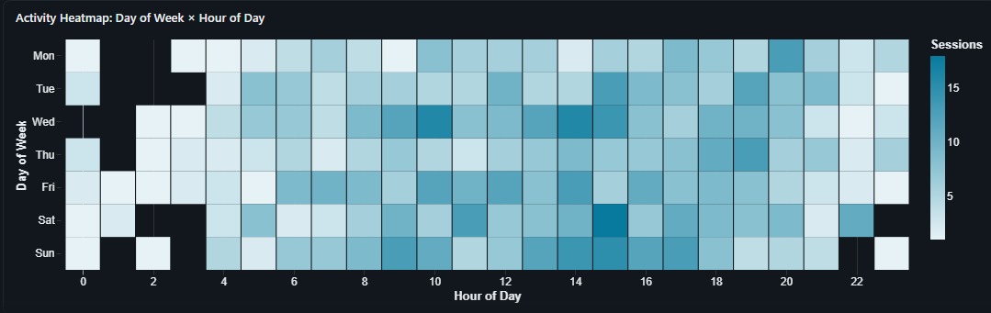
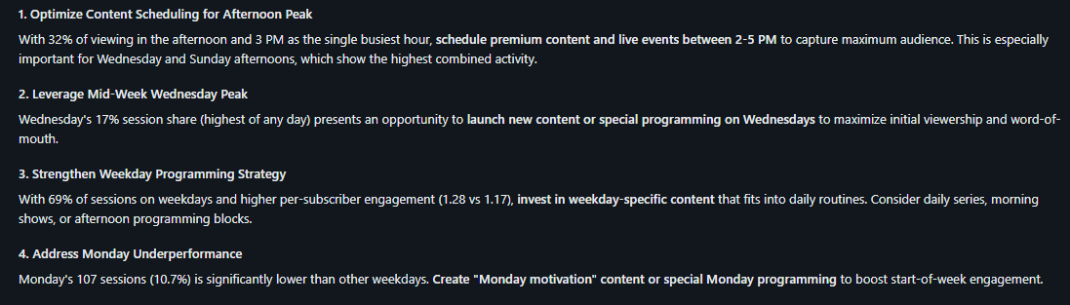
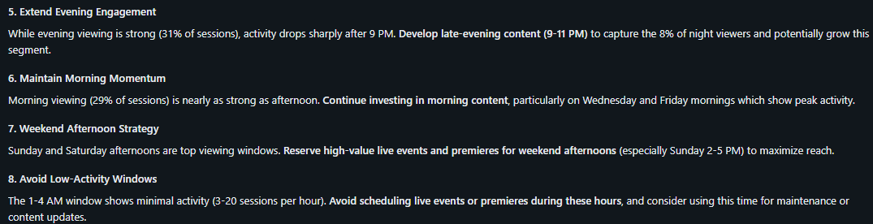
- Which periods show lower viewer activity, and what content would you recommend during those periods?
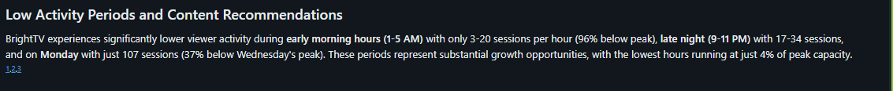
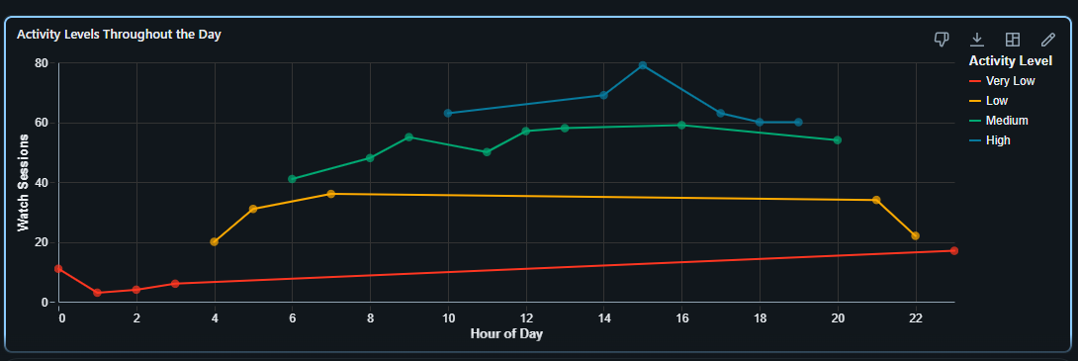
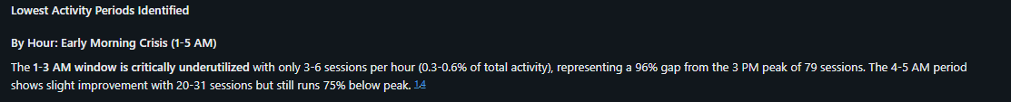
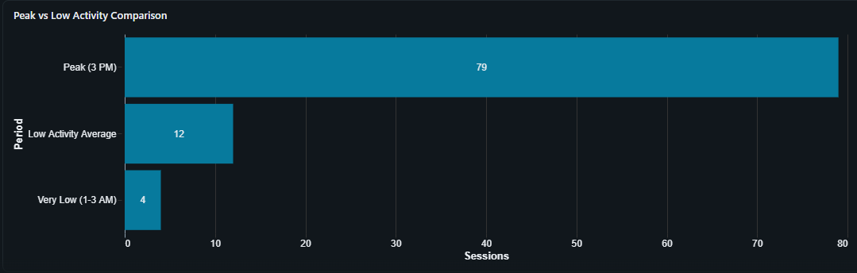
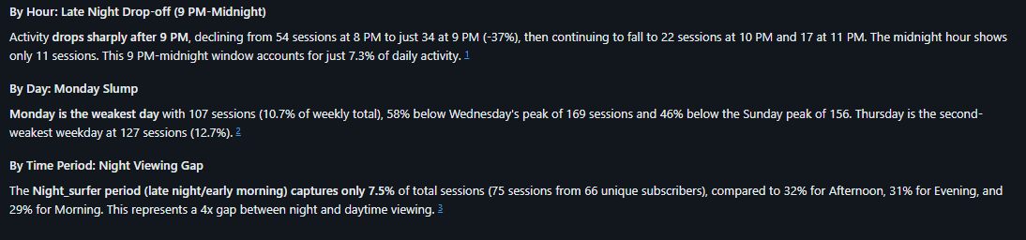
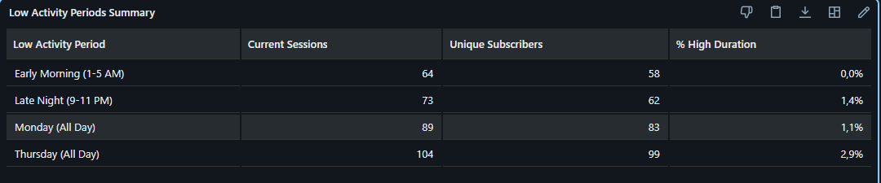
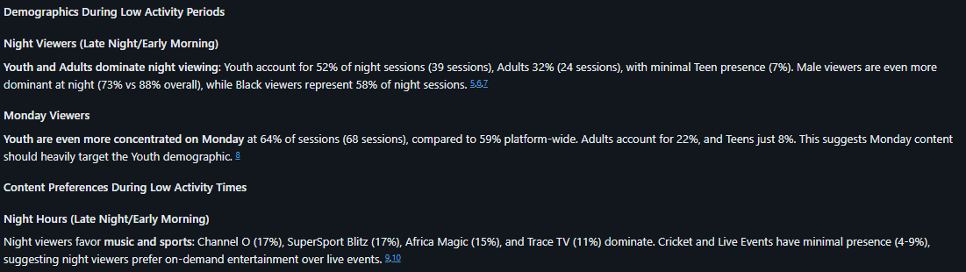
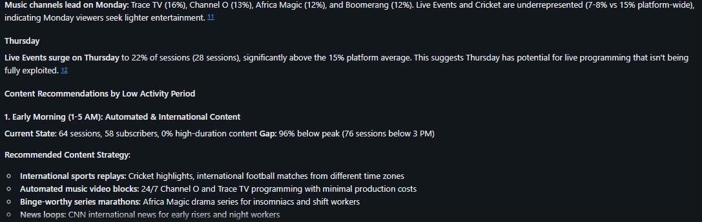
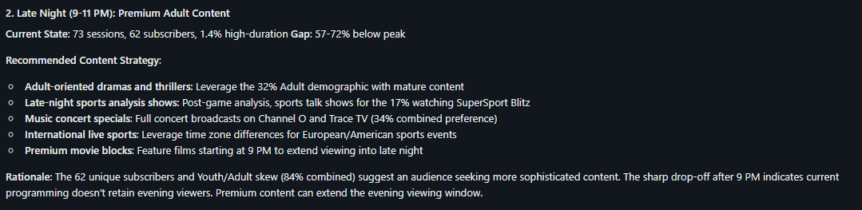
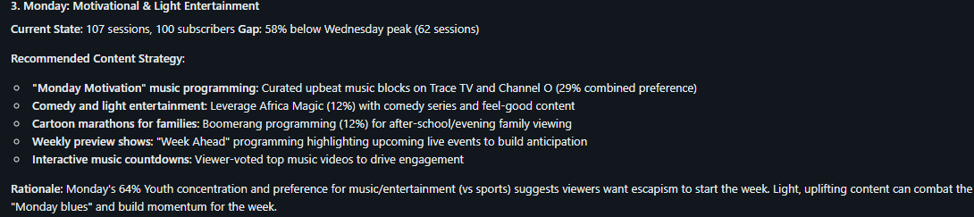
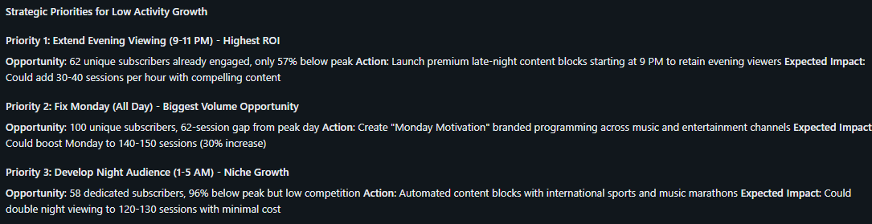
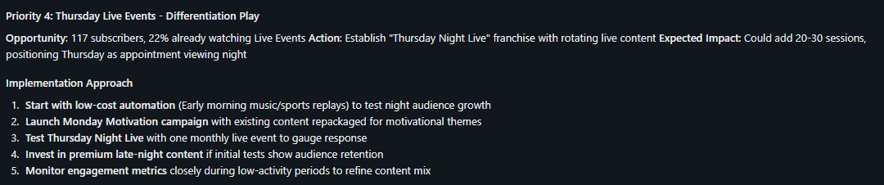
- Which KPI should management monitor weekly, and why?
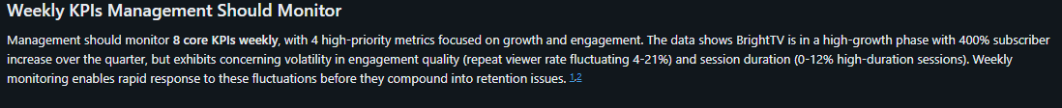
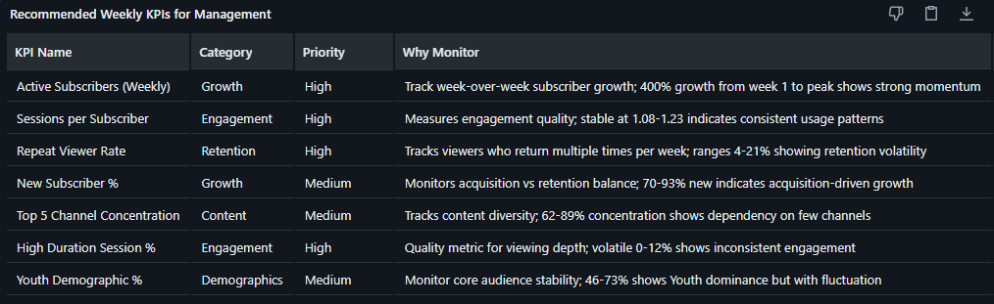
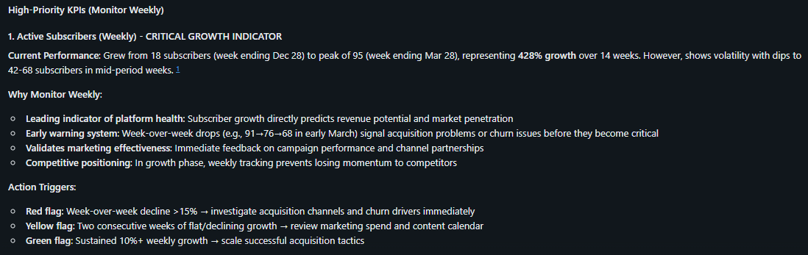
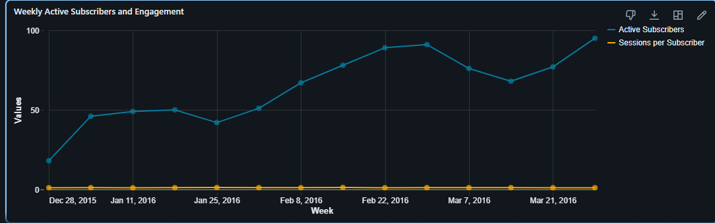
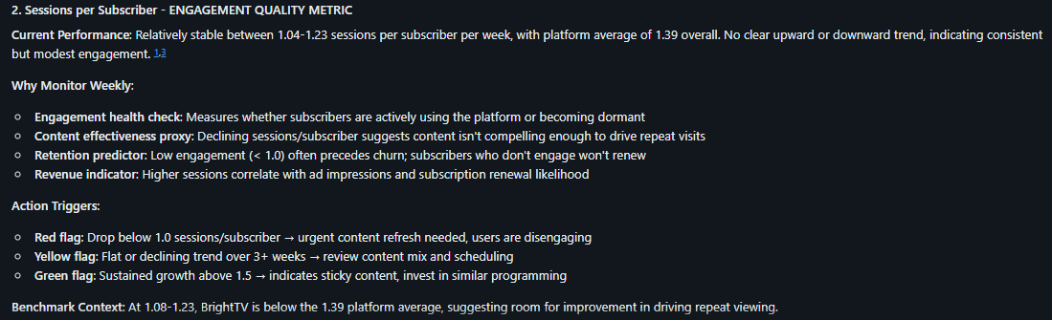
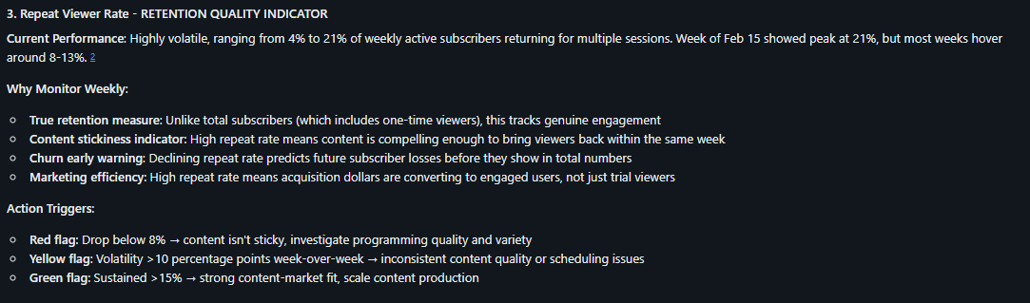
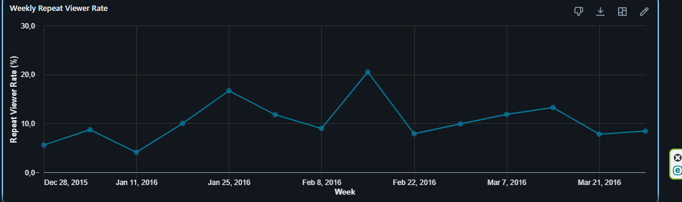
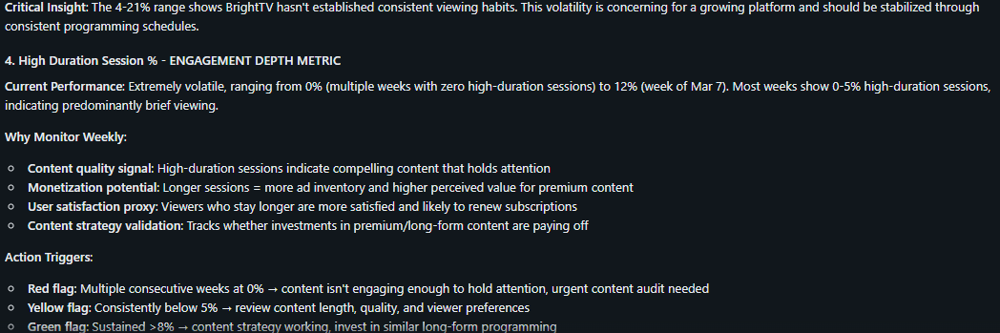
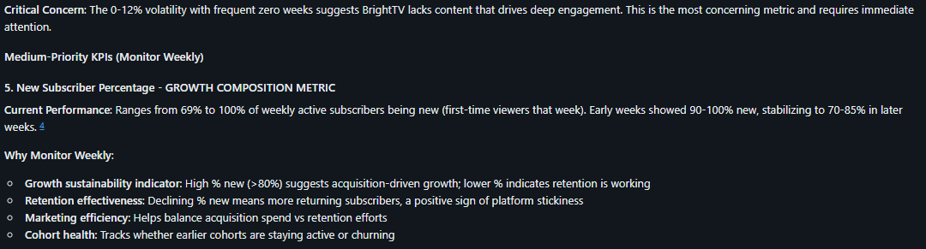
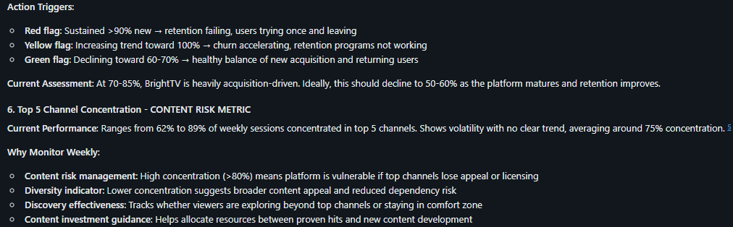
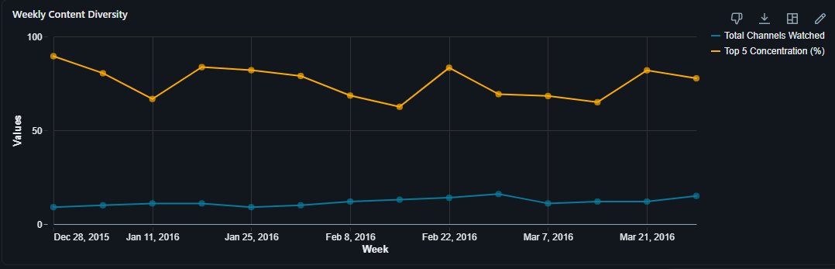
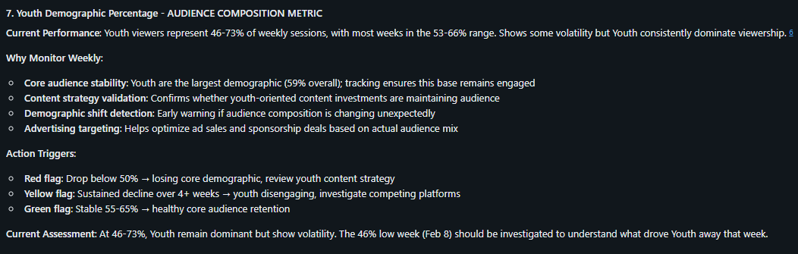
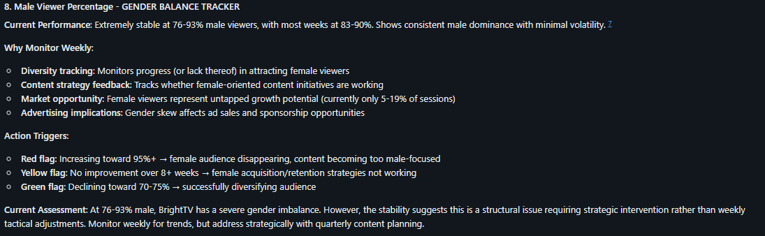
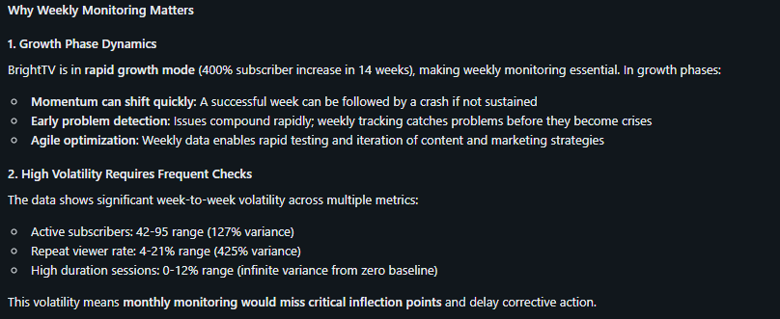
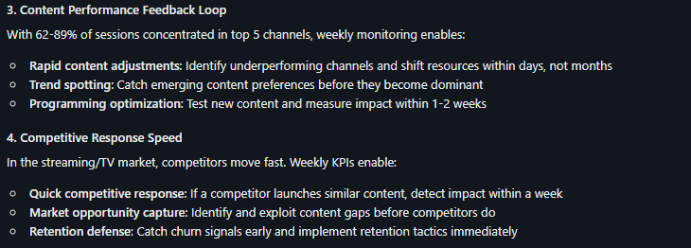
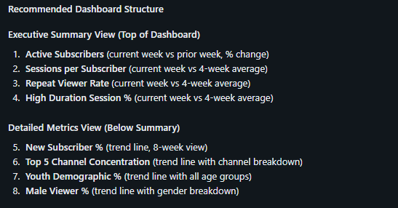
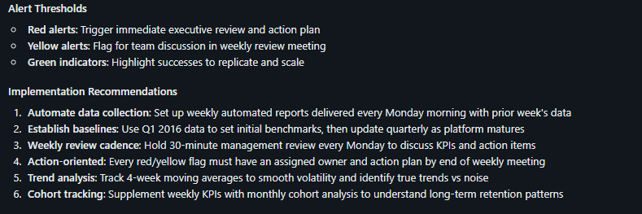
- How would you predict future viewing trends using this data?
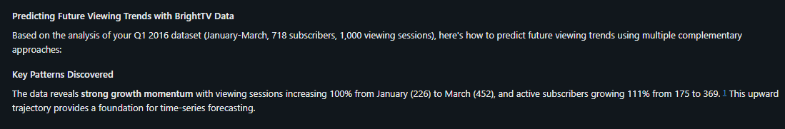
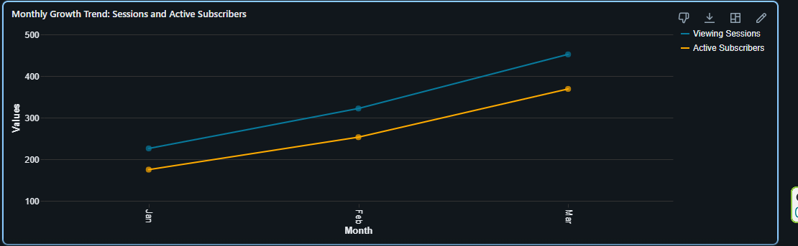
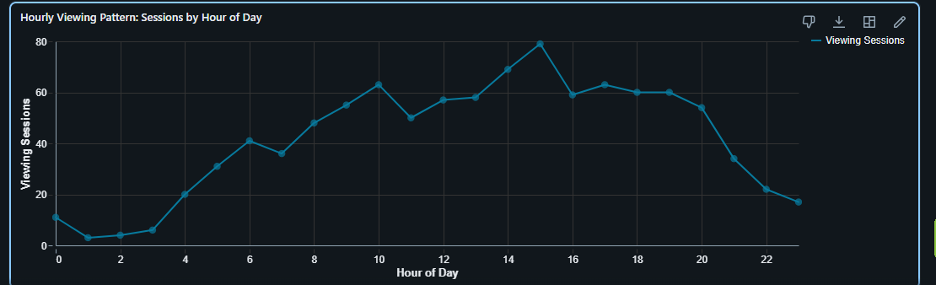
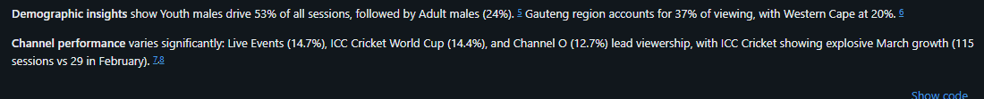
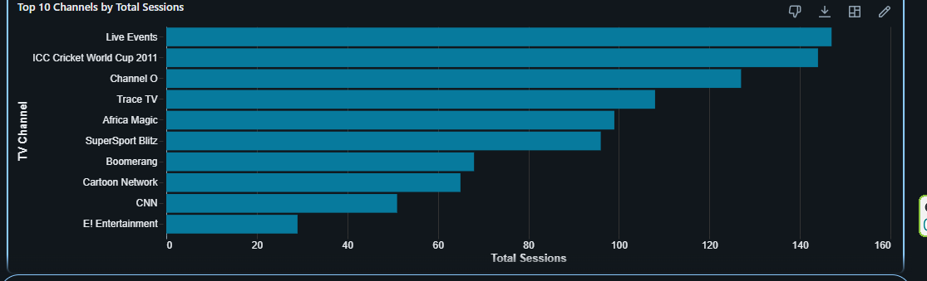
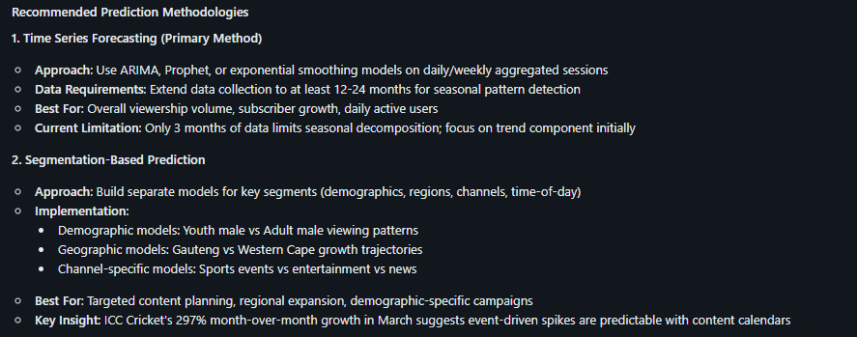
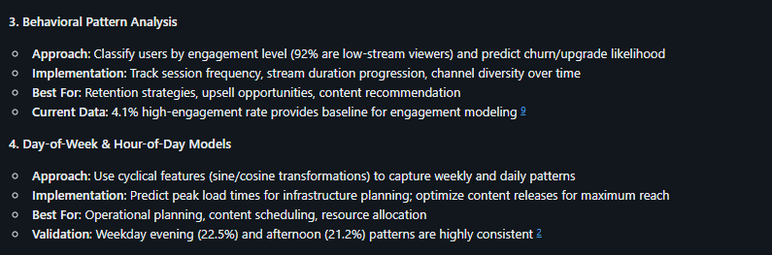
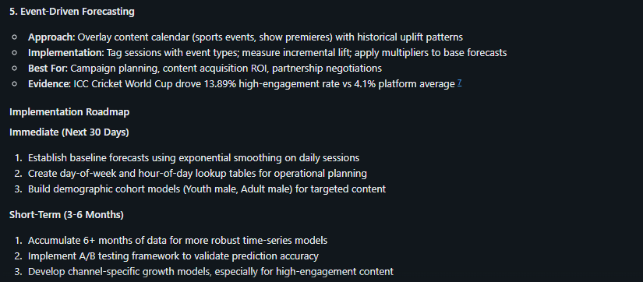
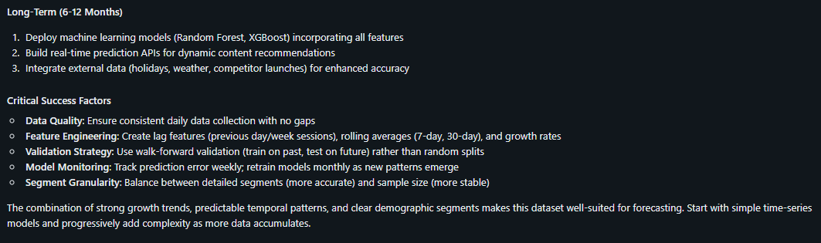
- What are the limitations of the current dataset?
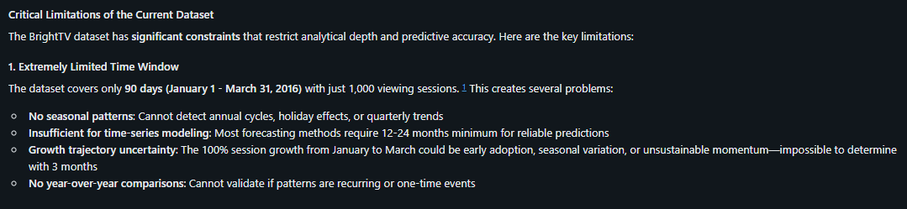
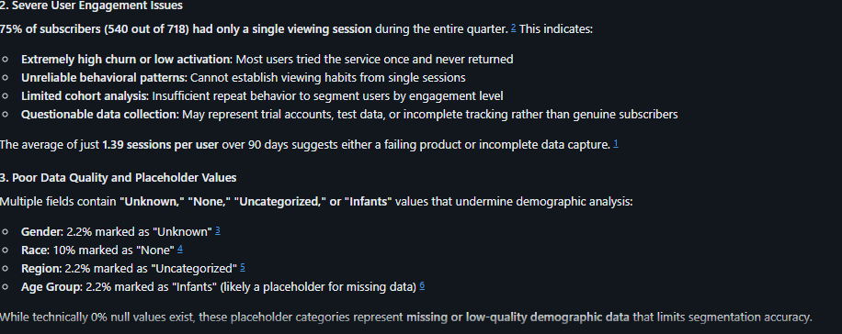
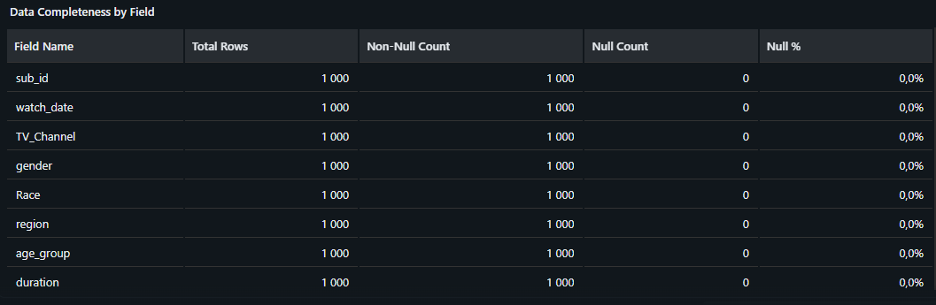
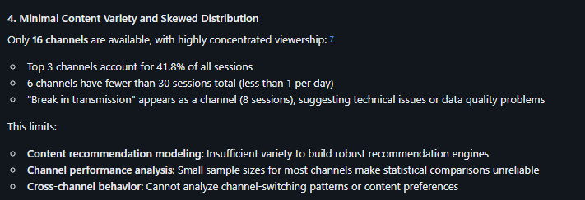
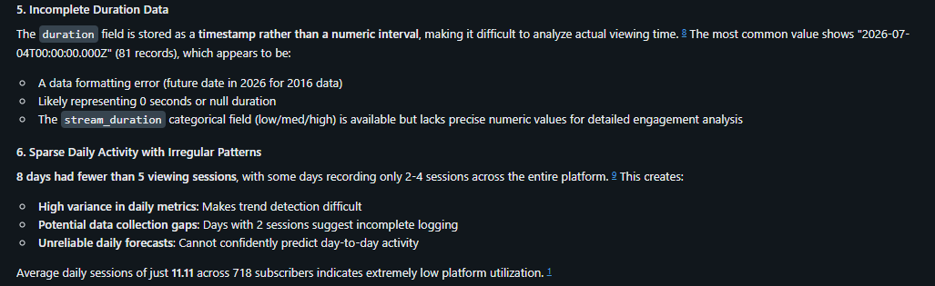
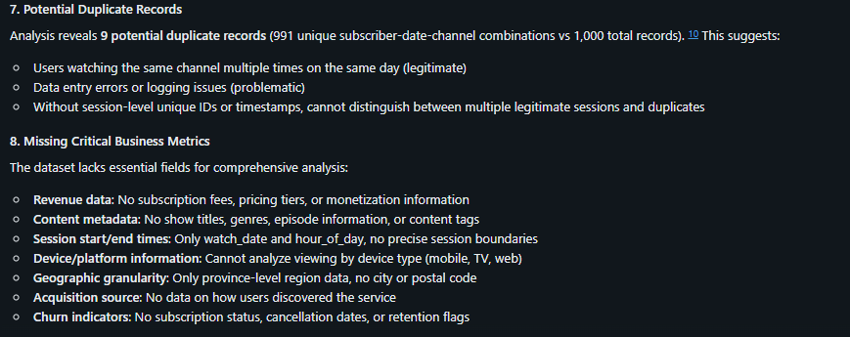
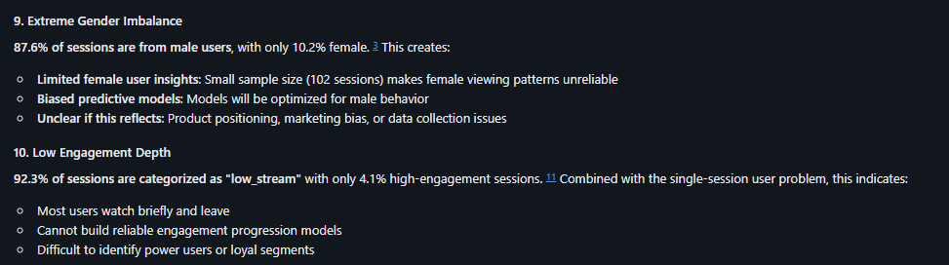
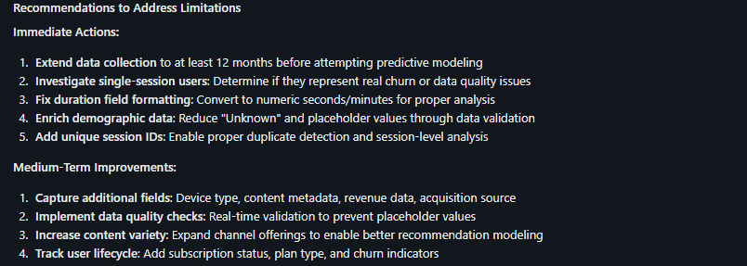
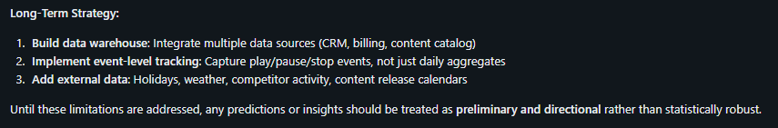
- Which customer segment has the greatest potential for future growth?
